CP411 Final Project Proposal

3D Traffic Jam

The standard Traffic Jam puzzle is a game where the goal is to move the main vehicle out of a 6x6 grid with other vehicles that serve as obstacles. The length of each vehicle is either two or three units in length, and can move in the direction each respective vehicle is oriented; also the main vehicle is always two units in length.

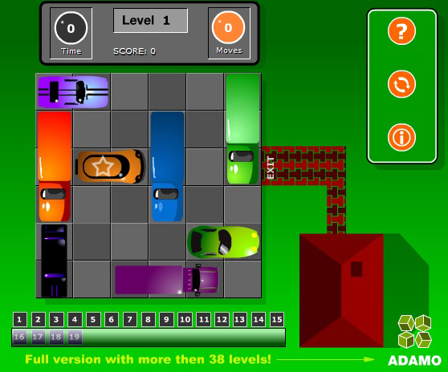

Figure 1: The car marked with a star, is the main vehicle

The standard game is usually tied, however in this final project, the focus is just to complete the puzzle and not how fast it can be done. By moving the other vehicles out of the path of the main vehicle, you are able to move the main vehicle towards the goal.

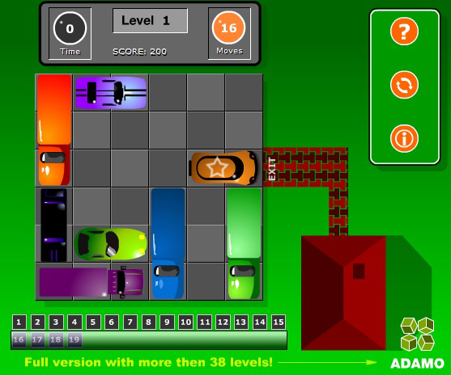

Figure 2: This is the final goal, where the vehicle has reached the exit

As part of the implementation of the 3D version being made, a user will have the ability to change the point of view of the puzzle as that user is completing it. They can click and drag the cursor to change the point of view with the left mouse button, so they can look at the puzzle from different perspectives. In order to be able to move each vehicle, the user must first be able to select it. Therefore the spacebar shall serve as a toggle switch to select between the ability to change the view of the puzzle, and the ability to select each car.

To prevent each vehicle from overlapping each other, there shall be a checklist to make sure that the vertices of the front or back face of the selected vehicle (depending on what direction the vehicle is moving) doesn’t not come within a certain distance to the vertices of other vehicles. To detect when the main vehicle has reached the goal, there shall be a decision structure checking to see of the vertices of the main cars front face has made it to the target.